|  |  |
| --- | --- |
| Critical Information Summary | |
| Student Name | CHUN KEUNG NG  ZiChao Kuang |
| SID | 214497259  215196936 |
| Mark Aimed For (%) | 70% |

### Code commits: Credit

* I have created 72 unique day commits.

### Weekly progress: Credit

* We did the changlog on github and attendant.php website, there are showing on what we did and what we done every week.

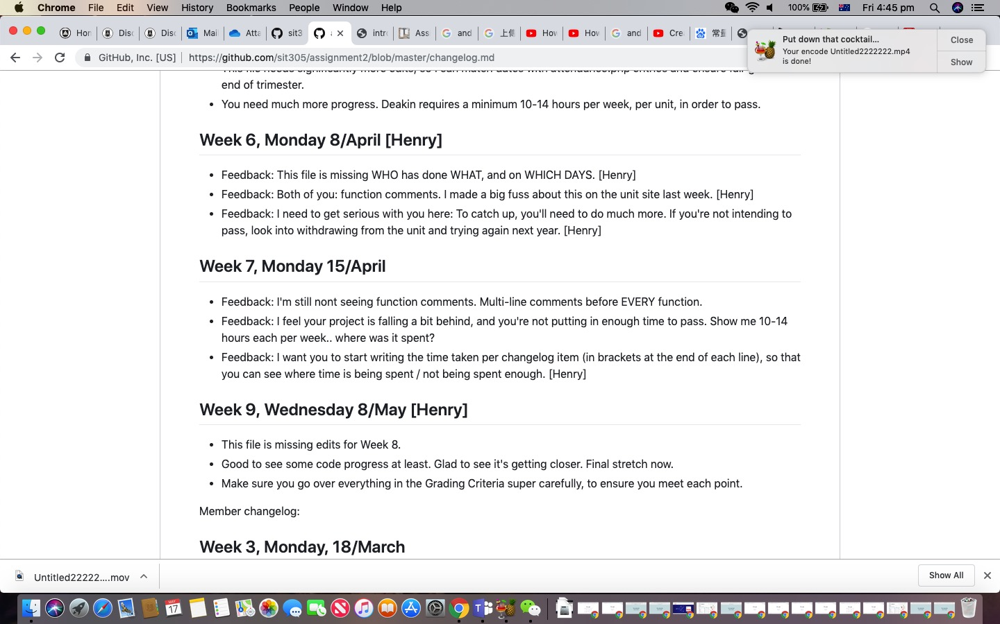

### Code quality: Distinction

* In the program, we invoke problem by inserting an external database.
* Using firebase to read, add user’s feedbacks.
* Using firebase to insert questions.

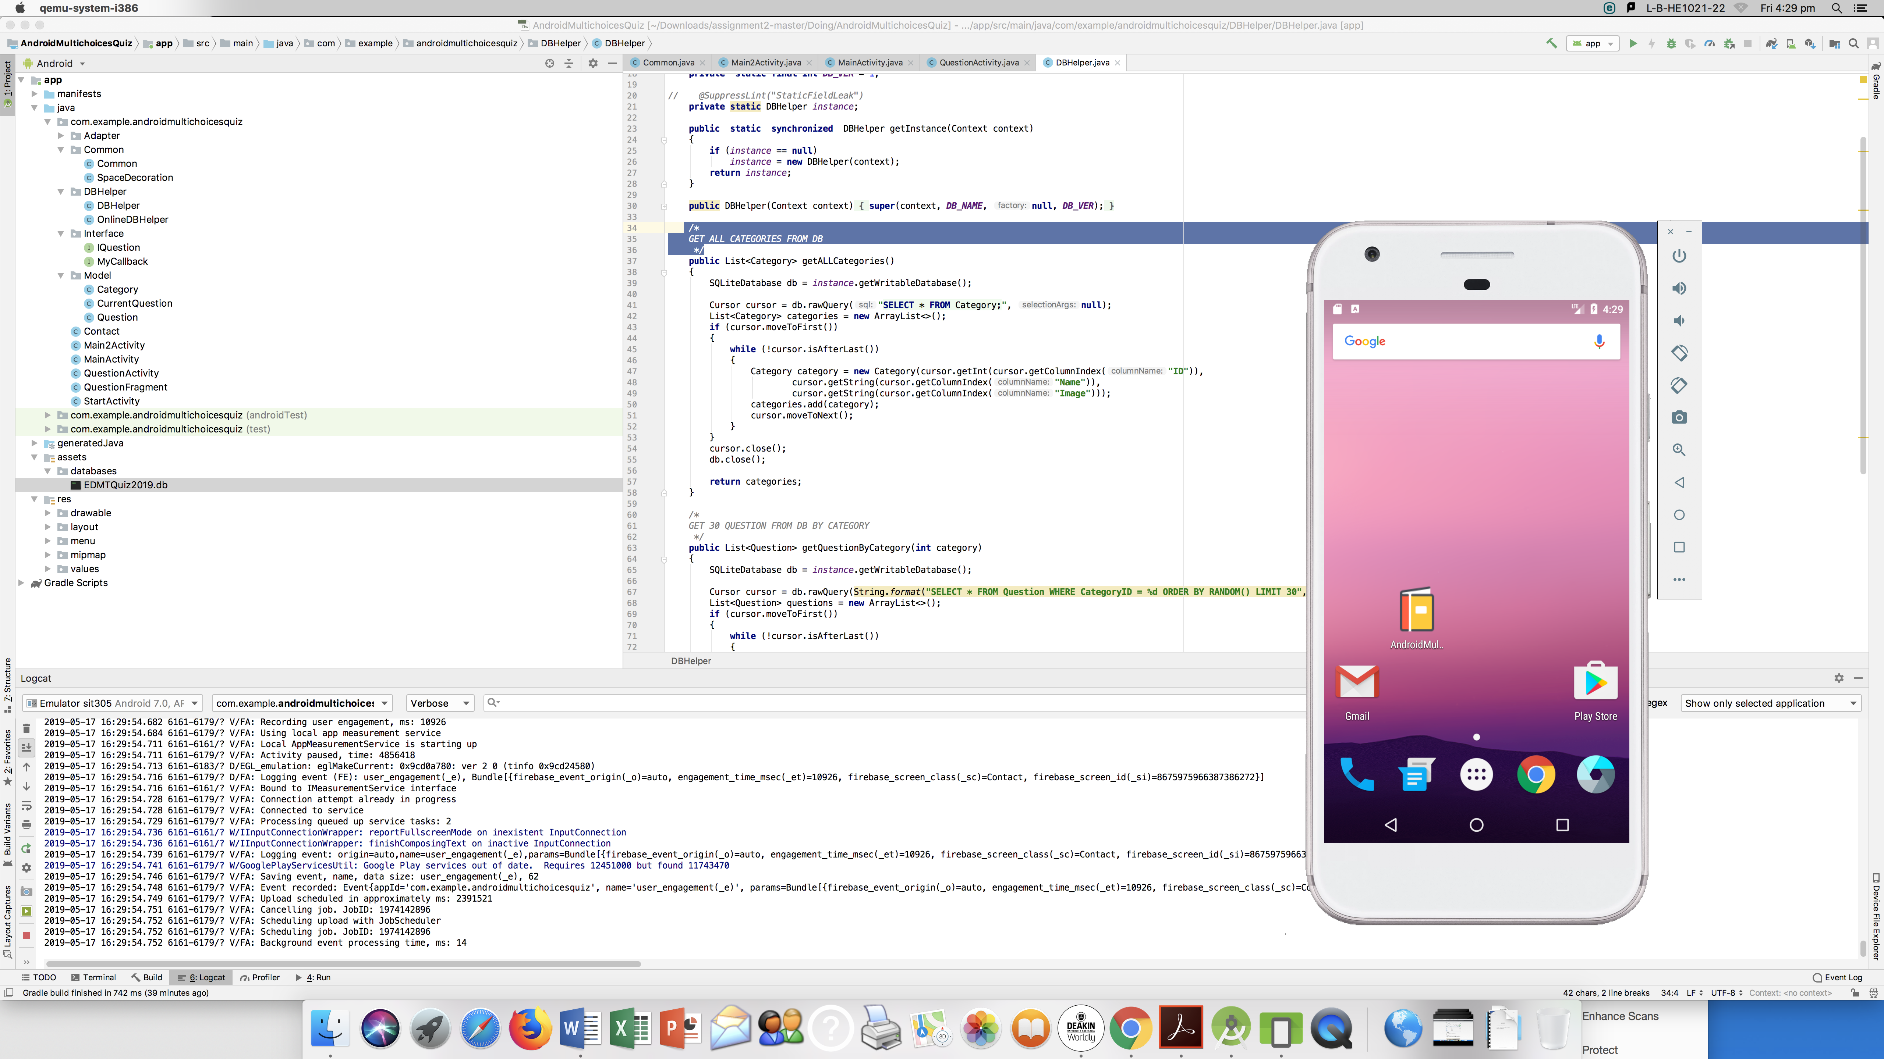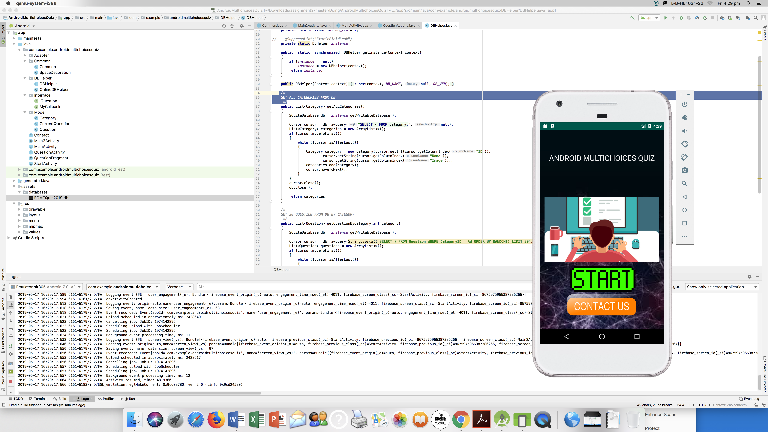

### Legal: Distinction

* Licenses.txt has provided.
* All the licenses included the websites are written to the source pages.

### Value: Distinction

* The value of this application depends on the user, because this is a simulate examination app.

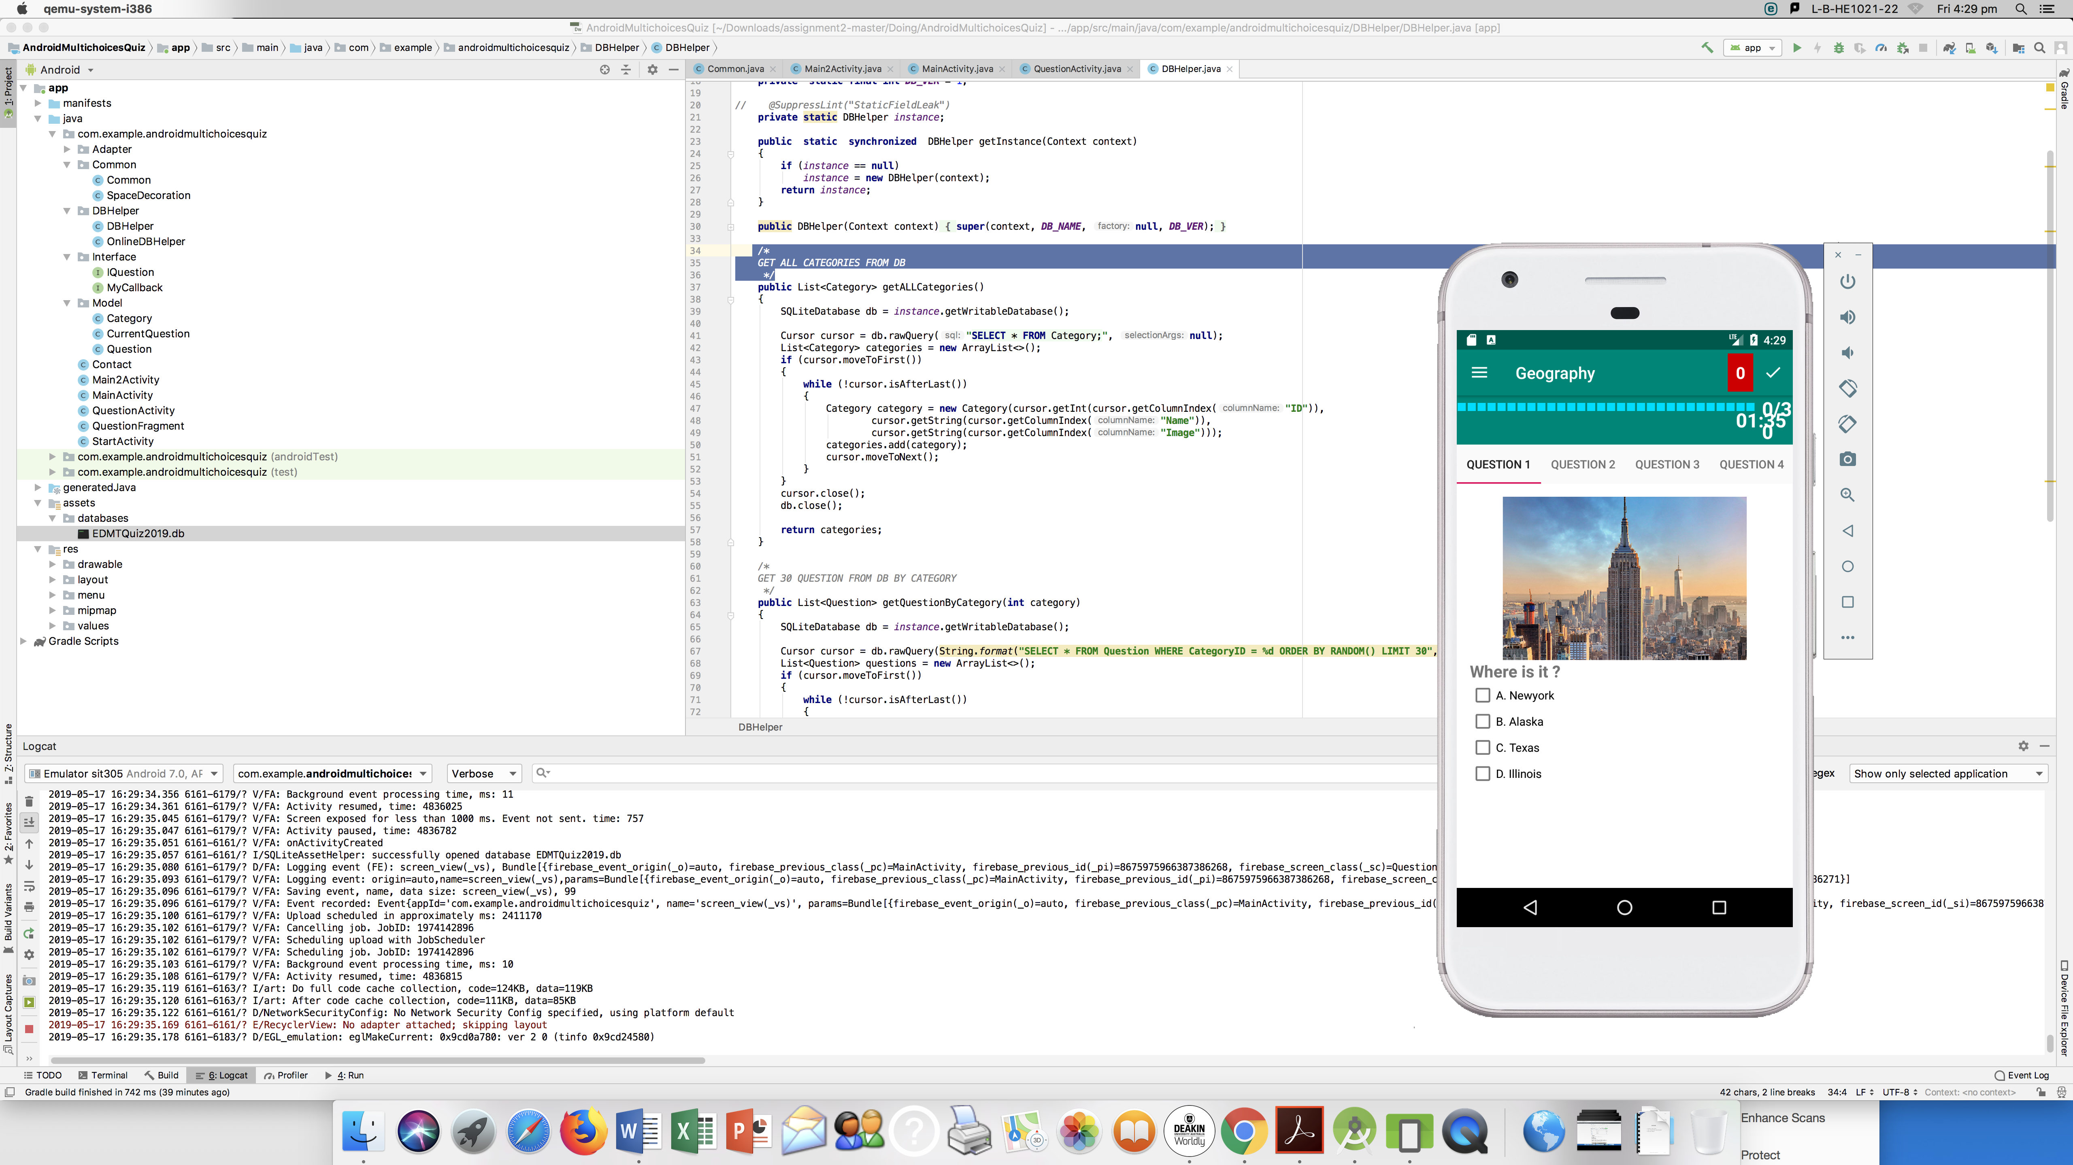

### Advanced Features: Distinction

* Firebase connector.
* Inserting an external database.
* Extract and push feedback in a real-time.
* Real-time extract database.

### Data Handling: Distinction

* Our data has saved and taken in the firebase which is the external database.

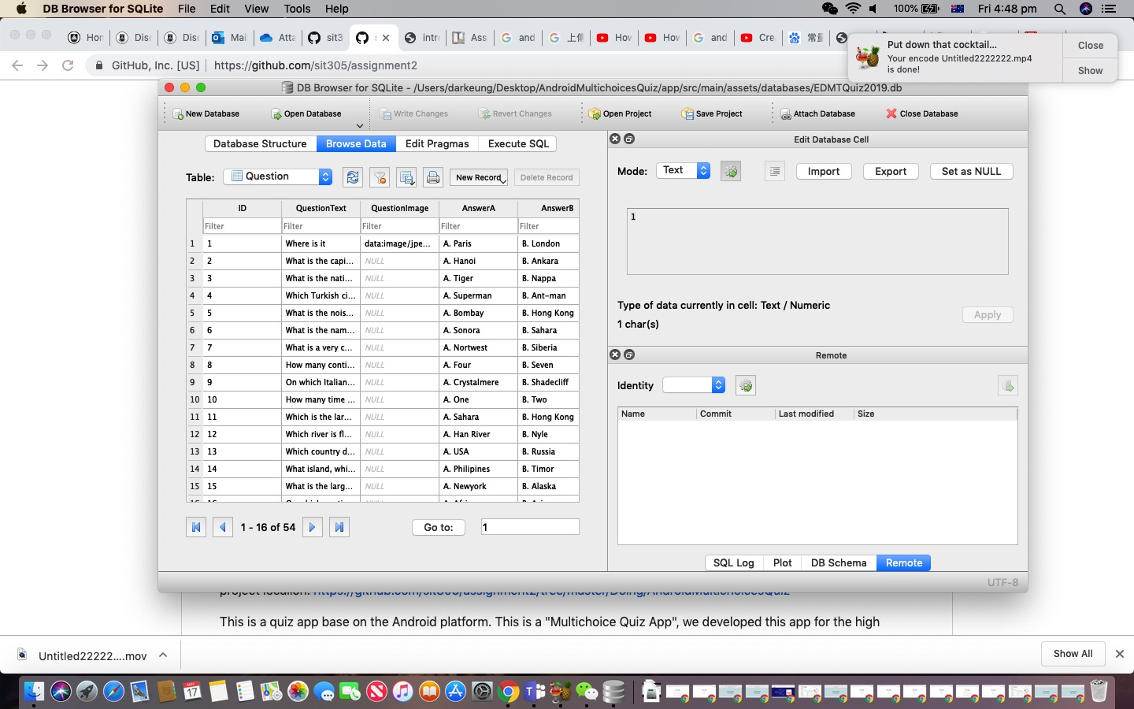

### Layout: Credit

* Our application can adjusts in real-time to changes in orientation and resolution.

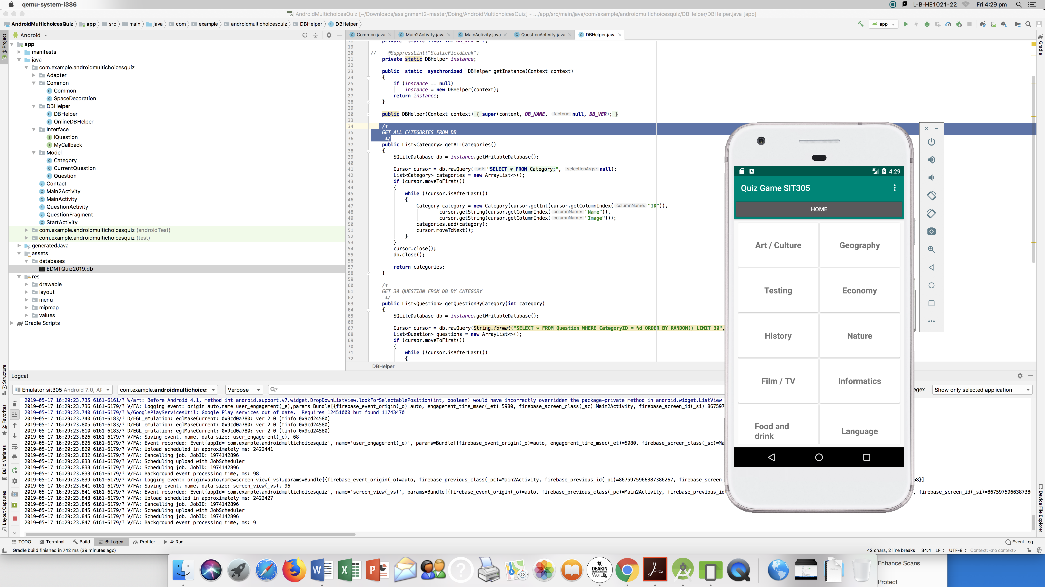

### Bugs: Distinction

* Our codes have a log page.
* Through the app runtime, all the bugs can be captured.

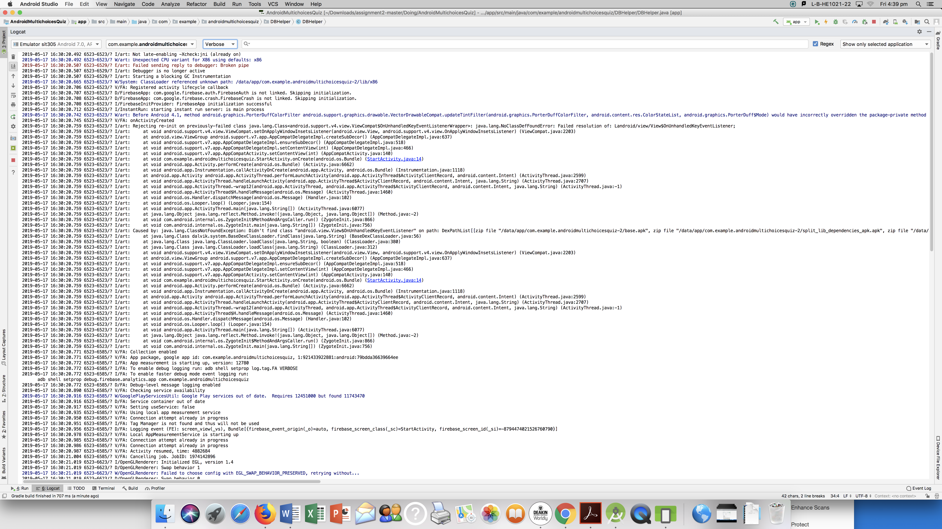

### Readme: Distinction

* Include name and student ID.
* Git link, project location link, intraduct pictures and videos of the project are included in this file.

### Publishing: Credit

* Our application has the folder of all promote text and screenshots per device.
* The icons and splash screens are saved in the local files.

### Demonstration Video: Credit

* The video has introduce all the functions our application covered.
* Our video is clearly for users to watch and audio is easy to understand.